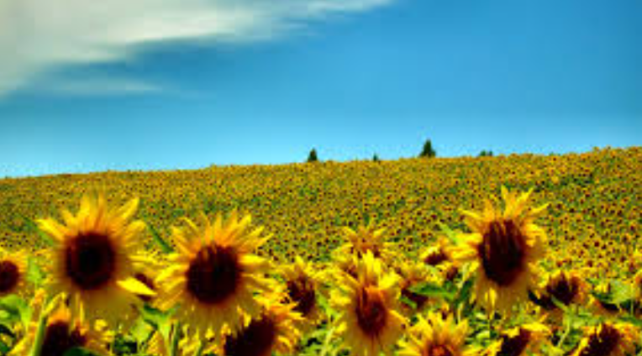 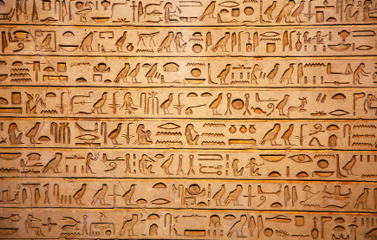

**Mathematics**

This term, we will continue to develop the children's understanding of fractions, decimals and percentages. Alongside our usual lessons, we will play games and take part in outdoor learning to explore fractions in the world around us.

**English**

This term, in our English we will begin by exploring and creating our own shape poetry. We will read and listen to a range of different shape poetry, discuss words that capture the readers interests and identify how language and structure contribute to the effectiveness of poetry.

**Science**

In Science, our topic this half term is ‘*Energy- sound and vibration’ by the end of the topic children should be able to* describe how sounds are made and heard through different mediums. Explain the relationship between vibration strength and volume. Talk about the relationship between volume and distance. Describe pitch and how to change it and explain how insulating materials can be used to muffle sound.

**Class 5 Autumn 2015**

Class 5 have an exciting and busy term ahead of them! A lot of our work will be based on the book ‘Kensuke’s Kingdom’ written by Michael Morpurgo,

‘A magnificent contemporary odyssey: a beautifully written account of a boy’s voyage of discovery. ‘

In Literacy we shall be exploring the story using several genres of text including; poetry, narrative, news reports and non-fiction texts.

**Geography and History**

Our big question in History is *‘How did the achievements of ancient Maya impact their society and beyond’*. The topic will link to our previous work on rainforests as we will begin by finding out about the challenges faced by the ancient Maya when settling in the rainforest. Then, we will research ancient Mayan beliefs, cities and the importance of chocolate to the ancient Mayans.

**How you can help**

Regularly listen to your child read and ask the questions about what they can remember about their school day. Encourage your child to practice their times tables – they all have logins for TT Rockstars and spellings on Spelling Shed. They will also have spelling homework sent home every Friday to support their learning.

**Class 2 Summer 2025**

**P.E**

During the summer term, we will be playing ball games and working on our throwing and catching skills. We will have lots of fun playing rounders (Mrs Hales’ favourite!) and finish the year with athletics. We will also practice for sports day nearer to the event.

**Art and Design**

* In art we will be exploring painting and mixed media – light and dark. Share their ideas about a painting.
* Describe the difference between a tint and a shade.
* Mix tints and shades by adding black or white paints.

**Religious Education**

We will consider the question ‘Why do Hindus want to be good?’

**PSHE**

We will be following the Jigsaw scheme and covering the topics ‘Relationships’ and ‘Changing Me’

**Computing**

This term, we will be looking at data handling by investigating the weather. We will record temperatures, design a weather station, search for the weather forecast information spreadsheet and explain how data is collected.